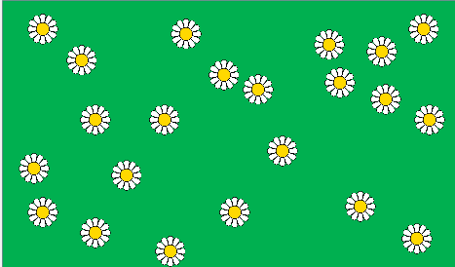
10 m
50 m
Quadrat to cut out

